BHP 2026 WOMEN IN RESOURCES NATIONAL AWARDS
Dyno Nobel Exceptional Woman in Australian Resources Award
This award recognises exceptional achievement in any occupation. It also recognises professional success, leadership skills, resilience, methods of overcoming barriers, and seeking out and accepting new responsibilities and challenges. It also acknowledges work to promote the industry’s reputation and standing in the community.

Finalists
Name | Company | State
Jody Altmann | GHD | Victoria
Alexandra Dandie | Rio Tinto | Northern Territory
Rae O’Brien | Thiess | Queensland
Tania Stevens | Eastern Guruma | Western Australia
Penny Woodward | Malabar Resources | New South Wales

Winner
Rae O’Brien
Group Executive Australia East, Thiess
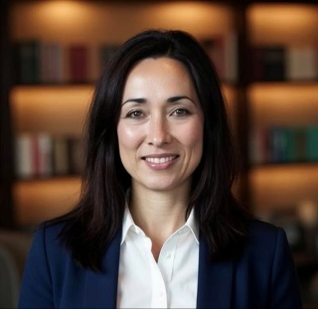 | Rae currently leads 13 major mining projects and more than 4,000 employees across Australia. A Mining Engineering (Hons) graduate, Rae has held senior operational, technical and executive leadership roles across the resources sector. She is recognised for driving operational excellence, advancing safety and innovation, and developing high-performing teams.  A passionate advocate for industry collaboration, research, education and inclusion, Rae has contributed through leadership roles with ACARP, the Queensland Resources Council and NSW Minerals Council. As one of Australia’s most respected mining leaders, she is committed to strengthening the capability, sustainability and future leadership of the resources industry.  Recognised for more than 30 years of contribution to the resources sector, Rae demonstrated significant governance, leadership and cultural change outcomes. Her nomination provided clear evidence of measurable impact, with the scale of her leadership, breadth of influence across the industry and sustained contribution positioning her as a standout in the category.

Mitsubishi Development Woman in Resources Technological Innovation Award
This award recognises the achievements of a woman who has developed and/or applied technological innovation in mining. It also recognises the innovative solutions that she has developed and applied in a unique/innovative way in the Australian resources industry.

Finalists
Name | Company | State
Dr Ainul Azzah Abd Aziz | Rio Tinto Gove | Northern Territory
Harriet Davies | Whitehaven Coal | New South Wales
Dr Humaira Ehsan | Hastings Deering | Queensland
Emma Eltringham | Woodside Energy | Western Australia
Man Ching (Christy) Tse | Newmont Corporation | Victoria

Winner

Dr Humaira Ehsan
Value Analytics Specialist, Hastings Deering
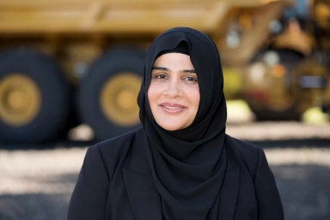 | Dr Ehsan is a Value Analytics Specialist, applying data science, modelling and systems thinking to improve supply chain decision-making for the resources sector. With a PhD in Information Technology from The University of Queensland and 15 years of academic experience, Dr Ehsan transitioned into industry to deliver practical, data-driven solutions. She led the development of SCORE, a Supply Chain Order Recommendation Engine that helps planners anticipate risk, reduce emergency orders and improve parts availability for mining customers.  Dr Ehsan is known for combining technical expertise, persistence and user-focused innovation to turn complex data into measurable operational outcomes.  Dr Ehsan was recognised for applying innovative thinking to deliver practical improvements in the workplace and measurable business outcomes. Through the effective use of technology and data, she demonstrated clear value creation and tangible impact, with her work improving the way information is used to support operational decision-making. Her ability to translate innovation into meaningful workplace outcomes distinguished her in a highly competitive category.

South32 Outstanding Tradeswoman/Operator/Technician in Australian Resources Award
This award recognises the achievements of a woman currently working in a trade, operator or technical role in Australia’s resources industry. The award recognises achievements in breaking new ground for women in non-traditional roles as well as resilience, achievement of goals and support for gender diversity.

Finalists
Name | Company | State
Sarah Berkin | Southern Cross Gold | Victoria
Kymberly Bouchardt | BMA | Queensland
Taleigha Everingham-Potts | Evolution Mining Northparkes | New South Wales
Rhondda Morgan | Newmont Tanami | Northern Territory
Sammi Rae | South32 | Western Australia

Winner

Kymberly Bouchardt
Field Supervisor, BMA
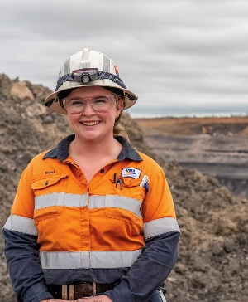 | Kymberly is a passionate advocate for women in trades and the resources sector. Beginning her career as an electrical apprentice, she has built experience across maintenance, continuous improvement and frontline leadership, now leading tradespeople and coordinating large maintenance teams in operational mining environments.  Kymberly is recognised for her commitment to workplace inclusion, apprentice development and mental health advocacy. Through her involvement with industry mentoring programs, the Tradie Lady Club, QMEA and The Shaka Project, she supports the next generation of tradeswomen and promotes positive cultural change across the industry. She is currently completing a Bachelor of Behavioural Science.  Kymberly was recognised for her dedication to her trade, strong career progression and across workplace, community and industry settings. Her nomination demonstrated a sustained commitment to supporting others and advocating for her trade while continuing to build influence beyond her immediate workplace. Her broader influence and contribution, credibility and impact made her the unanimous choice for the category.

